WEDE5020
Web Design and development

Website Project Proposal

Luminous industries
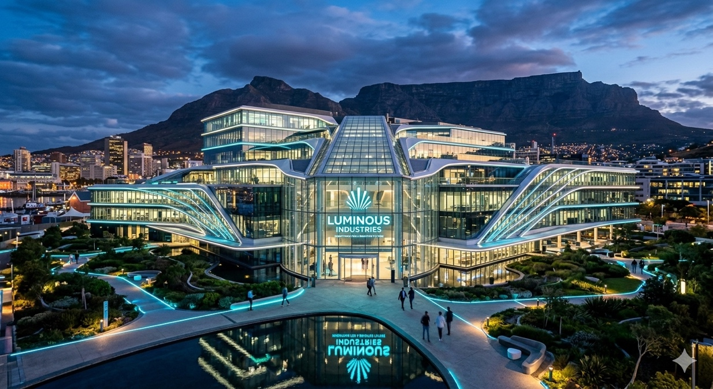
Submitted by :
Lucas Bombamba
ST10500220

Table of contents
1. Organisation Overview
2. Website Goals and Objectives
3. Current Website Analysis
4. Proposed Website Features and Functionality
5. Design and User Experience
6. Technical Requirements
7. Timeline and Milestones
8. Budget
9. References

Organization Overview

Name: Luminous Industries
Brief History:
Founded in 2012, Luminous Industries began as a small startup focused on sustainable lighting solutions. Over the years, it expanded into renewable energy technologies, smart infrastructure, and eco-friendly manufacturing. Today, it is recognized as a pioneer in combining innovation with environmental responsibility.

Mission Statement:
To illuminate the world with sustainable technologies that empower communities and protect the planet.
Vision Statement:
A future where every city shines with clean energy, smart design, and sustainable growth.
Target Audience:
Municipal governments seeking smart city solutions
Businesses aiming to reduce their carbon footprint
Global organizations focused on renewable energy adoption

2. Website Goals and Objectives
Primary Goals:
Showcase Luminous Industries as an innovative leader in tech solutions.
Generate qualified leads through product/service inquiries.
Provide valuable resources (whitepapers, case studies, blog posts).
Increase brand visibility and website traffic.

Key Performance Indicators (KPIs):
Monthly unique visitors.
Conversion rate (inquiries, demo requests).
Average session duration.
Newsletter sign-ups.

3. Current Website Analysis (if applicable)
Strengths:
Strong brand identity in tech innovation.
Clear product/service offerings.

Weaknesses:
Limited interactive features.
Outdated design not optimized for mobile.
Areas for Improvement:
Enhance mobile responsiveness.
Improve SEO and content strategy..

4. Proposed Website Features and Functionality
Essential Pages:
Homepage (highlighting innovation and core services).
About Us (company mission, vision, leadership).
Products/Services (detailed descriptions, demos).
Contact Page (form, chatbot, direct email).
Blog/Insights (industry trends, company updates).

Desired Functionality:
Interactive product demos.
Lead capture forms integrated with CRM.
Search functionality.
Newsletter subscription.
Secure client portal for existing customers.

5. Design and User Experience
Colour Scheme: Futuristic palette (deep blue, silver, neon accents).
Typography: Modern sans-serif fonts (e.g., Montserrat for headings, Open Sans for body).
Layout and Design:
Clean, modular grid system.
Prominent call-to-action buttons.
Visual storytelling with tech imagery.
User Experience Considerations:
Intuitive navigation with dropdown menus.
Mobile-first responsive design.
Accessibility compliance (WCAG standards).

Wireframes:
Low-fidelity sketches to map homepage hero section, product/service cards, and blog layout.

6. Technical Requirements
Hosting & Domain:
Secure hosting with scalable cloud infrastructure (e.g., AWS, Azure).

Domain name: luminousindustries.com with SSL certificate for security.
Programming Languages & Frameworks:
Frontend: HTML5, CSS3, JavaScript (React.js for dynamic UI).
Backend: Node.js with Express framework.
Database: PostgreSQL or MongoDB.
CMS: Optional integration with WordPress or headless CMS (e.g., Strapi).

Additional Tools:
GitHub for version control.
CI/CD pipeline for automated deployment.
Analytics integration (Google Analytics, Hotjar).

7. Timeline and Milestones
Week 1–2: Requirements gathering, wireframes, and design mockups.
Week 3–4: Frontend development (homepage, navigation, core pages).
Week 5–6: Backend setup (database, APIs, authentication).
Week 7: Integration of features (blog, client portal, lead forms).
Week 8: Testing (unit tests, usability testing, mobile responsiveness).
Week 9: Deployment to production server.
Week 10: Post-launch review and optimization.

8. Budget
Development Costs: R127,330 - R190,995
(depending on complexity).
Hosting & Domain: R4,775 - R7,958 annually.
Maintenance & Updates: R3,183 - R4,775 per year.
Marketing & SEO: R23,874 - R39,790 initial investment.
Total Estimated Budget: R19,099 - R28,649

9. References
Industry best practices in web development
https://ellow.io/what-is-web-development-framework/

UX/UI design guidelines from Nielsen Norman Group.
https://medium.com/@pixelz3601/web-design-frameworks-and-their-influence-on-development-workflow-41cd82b462cb

Hosting and domain pricing research
https://www.hostinger.com/tutorials/domain-vs-hosting

SEO optimization strategies
https://www.experian.ie/content/dam/marketing/uki/ireland/ie/assets/decision-analytics/brochures/strategy-optimisation.pdf

